Dear Sir

I would like to appreciate you for the consideration and your valuable time to spend with us.

**GPS tracking system**

GPS system is the device used to track the live position of the vehicle by using a Sim. A small device is installed in the vehicle where this device consist of Sim which helps to trace the location of the vehicle.

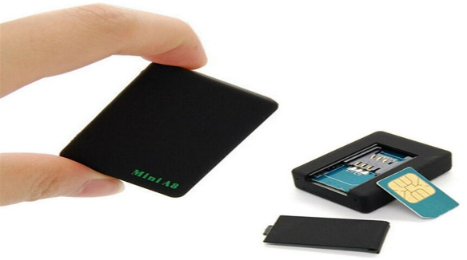

**Why GPS system ??**

1. Live tracking
2. Fleet management
3. Misuse alerts
4. Saftery of drivers,vehicles and environment
5. Theft detection

**Benefits of GPS**

* Cost savings
* Increased productivity
* Reduced time consumptions
* Alerts

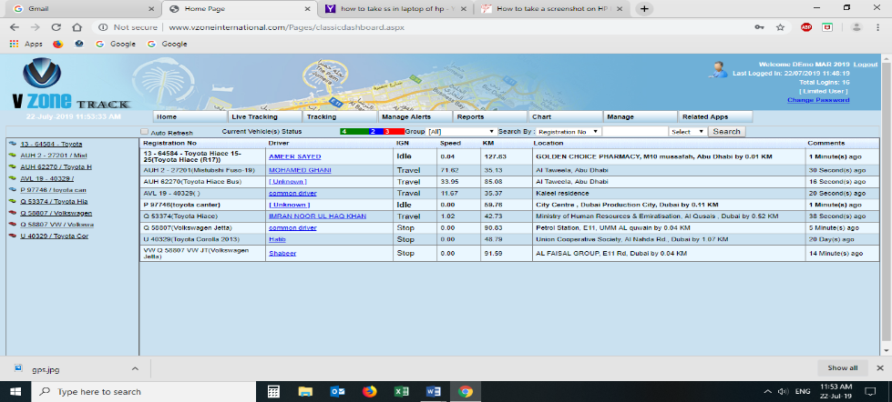Software used for this technology is simple and convenient to use which can either used from your PC or mobile.

How to use the software:

* Search for VZone international from Google.
* Login page for the users.
* one unique username and password for the users
* Home dashboard which gives the details of the vehicles.

Figure shows the home dashboard of the users

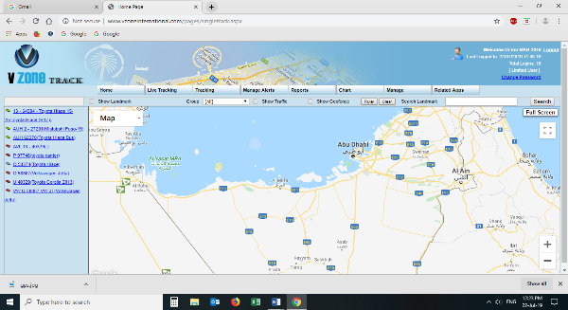**Dash board details:**

**HOME**

* Vehicle number and model
* Driver name (can be added as per our requirements)
* Ignition status of the vehicle (travel, stop, idle)
* Exact location of the vehicle
* Comments update status

(Green =travel, Red = stop, Blue= idle)

USES:

* This page is used for the easy understanding of the vehicle details that are connected with the gps tracking system

**Live tracking**

* Single tracking and multi tracking

This tool is used if you got more than one vehicle in your company to trace the exact location of the vehicle.

**USES:**

* Single tracking system helps to find out a single vehicle location at time, which will help to know the location of the vehicle preferably say it’s much more useful in courier services.
* When it comes multi tracking system we can directly check the vehicles that are controlled by the system (more than one at a time), so that we can check which is nearby and reduced the time consumptions. This will be much more useful in online taxi booking services.

**Track record**

Used to trace the route map of the vehicle travelled throughout the day

Uses:

* We can check the misuse of vehicle by the drivers like took different routes for his personal purposes
* What and all was the driver activities today where he went as per the schedule

**Manage alerts**

To find out the misbehavior of the driver like excess speed, hard breaking, excess idle timing

Uses:

* Will help us to give right information to the driver about the speed, traffic, delay start, delay stop
* Spot necessary actions can be taken with out delays.

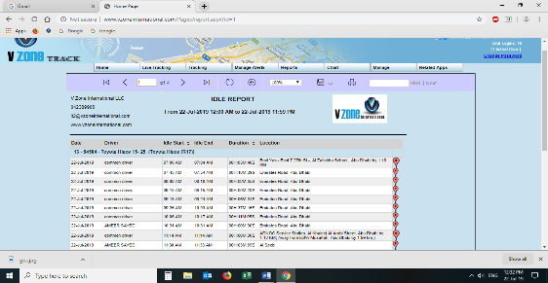

**Reports**

Used for the details of alerts, timings, cars, excess idle timing and so on.

Uses:

* Monthly reports, weekly reports, daily reports of the vehicle like how long it has been travelled, idle position and stop condition, rash drive reports
* Helps to find out the exact person at exact time and position

**Special characters for users:**

* Vehicle service details
* Alarm alert
* Ignition on/off by users
* Easy access from mobile
* 2 way communication system
* Audio recording system
* 2 year replacement guarantee
* 24*7 call Centre assistance